**Name of the Author**: Madhusree Rana

**Project** **Name**: Hand Gesture Recognition

**Programming** **Language** **used**: Python

**Project** **Description**:

* Modules used:-
* Open Source Computer Vision (OpenCV)
* Mediapipe

The project uses “MEDIAPIPE”, a framework provided by Google, that offers cross-platform, customizable ML solutions for live and streaming media. With the help of Mediapipe and the video captured using webcam, the project helps in counting the number of fingers shown by one human hand, and detects the alignment of the thumb, and by detecting which fingers are raised and which are closed, it detects and displays the corresponding hand gesture on the video being shown, all in real time.

The project makes use of the 21 landmarks of the human hand, marked from 0 to 20, in order to detect whether the finger(s) is/are raised or put down.

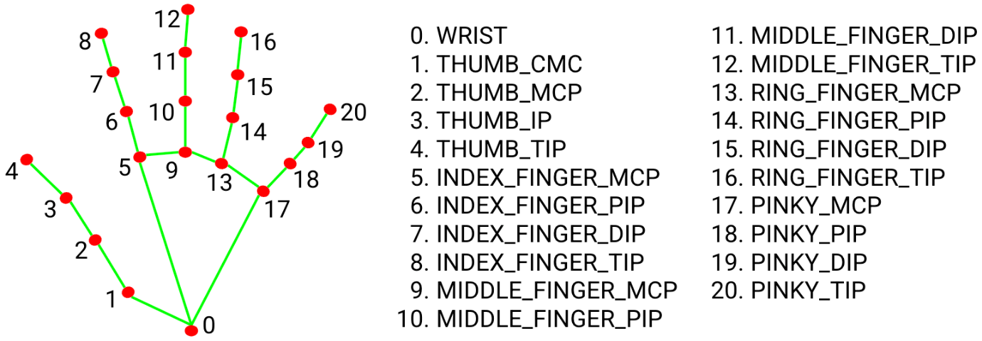

Image Source: [**https://google.github.io/mediapipe/solutions/hands**](https://google.github.io/mediapipe/solutions/hands)

For knowing more about Mediapipe, go to:

[**https://google.github.io/mediapipe/**](https://google.github.io/mediapipe/)

For knowing more about Hand detection using Mediapipe, go to:

[**https://google.github.io/mediapipe/solutions/hands**](https://google.github.io/mediapipe/solutions/hands)